**How to debug an Autohotkey script**

(From <https://www.autohotkey.com/docs/AHKL_DBGPClients.htm>)  
  
I’ve successfully used “SciTE4AutoHotkey”…  
  
1. Download the Portable Zip from here: <http://fincs.ahk4.net/scite4ahk/>  
Extract the zip somewhere – you should have these files and directory:  
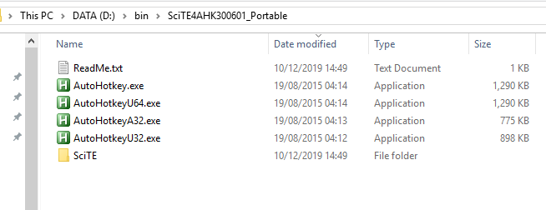  
  
2. Launch “D:\bin\SciTE4AHK300601_Portable\SciTE\SciTE.exe”  
  
3. Open your ahk file in the editor:  
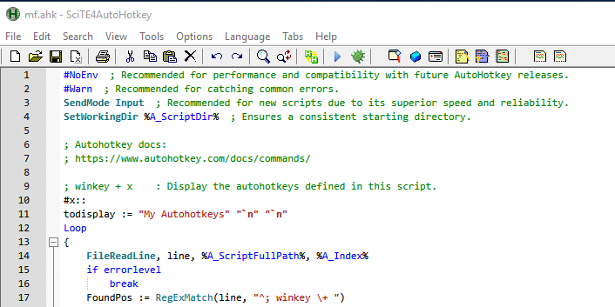  
  
4. Set a breakpoint, by clicking to the right of the line number:  
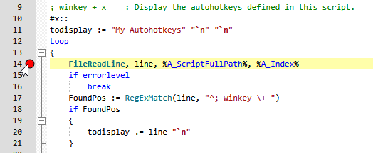

5. Click the Debug button:   
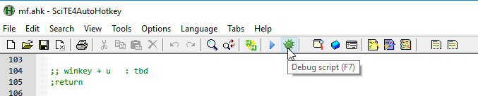  
  
6. Now click the Run button:  
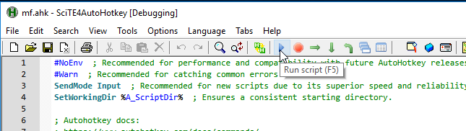  
  
7. Trigger the action, e.g. using “winkey+x”.   
Your breakpoint should be hit:  
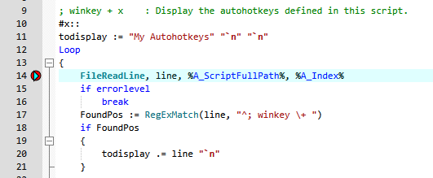

**END**  
*JeremyC 18-12-2019*